Project Proposal

Student Details

Full Name (Surname, Forename(s))
Gursimran Singh

Student Number
2042387

Award/Course
BSc Computer Science

University Email
g.singh280@wlvv.ac.uk

Full Name of Supervisor and Reader (if known)
Frommholz Ingo

Date of Submission
20th October 2022

Content
Student Details 1
Full Name (Surname, Forename(s)) 1
Student Number 1
Award/Course 1
University Email 1
Full Name of Supervisor and Reader (if known) 1
Date of Submission 1
Content 2
Statement of Project Details 3
Project Title 3
Academic Question 3
Aims 3
Objectives 3
Artefact (proposed) to be developed 3
Project Proposal 4
Introduction 4
Initial Research into sources of information 5
Artefact(proposed) 6
Plan/Schedule 7
References and Bibliography 8
Additional Information 9
Resources 9
Client 9

Statement of Project Details

Project Title
Web app or Native app

Academic Question
What application performs better on a mobile device: native app or web app?

Aims
The Aims of the project I am planning to develop will be:
- To Investigate the differences between native and web app.
- To compare the advantages and disadvantages of native mobile app and web app.
- To Implement a complex native app and a web app.
- Test both the applications using appropriate tools and methodologies.
- Evaluate the result.

Objectives
The Objectives of the project I am planning to develop will be:
- Investigate the main features of a native mobile app.
- Investigate the main features of a web app.
- Investigate the advantages and disadvantages of native mobile app.
- Investigate the advantages and disadvantages of web app.
- Create and set-up a database to store data.
- Design a user Interface for the native app and for the web app.
- Develop the native app.
- Develop the web app.
- Test the native app and the web app.
- Compare the result of the testing.
- Answer the Academic Question.

Artefact (proposed) to be developed
The aim of this project is to compare a native mobile app and a website built for mobile. Therefore, I will be building two artefacts: a website and a mobile app. Both of artefacts will access a back-end database via Java or C# (mobile app) and PHP or JavaScript (website). The mobile app will be developed using Java and XML on Android Studio (subject to change). The website will be developed using HTML, CSS and JS. The main feature of these applications will be to allow users to upload images or videos of a certain location and to view images or videos uploaded by other users.

Project Proposal

Introduction
In a world where the technology is advancing rapidly, mobile devices have become part of the routine of the majority of the people. These devices that were used only to call or text thirty years ago, nowadays are used to access the Internet. The application that mobile devices has is wide, as these devices are used for entertaining, learning, communicating, navigating and for doing business.
The purpose of this project is to see if a website developed for a mobile device (web app) can perform the same task that a native app can do and which of these offers the best experience to the user.
The project will start off by investigating the latest features of websites and native mobile apps. Following on, an investigation of any past research where the performances of the two applications are compared will create solid fundaments. The next step will be to investigate databases that will be used as backend for both the applications, the IDE that will be used to develop both the applications and therefore there will be a focus on the languages that these IDEs uses.
The next step of the project will be to design the web app, the native mobile app and the database. In this phase all the results of the investigations done previously will be used to create a more detailed plan of all the features and all the applications that will be used in the implementation phase.
The first step of the implementation will be the creation of the database, this database will store all the data coming from and used by the native mobile app and the web app. The structure of the databases will be key as if done correctly it will make the following steps of the implementation much more easy-going.
The development of the two applications will be parallel, so if the login page has been implemented in the web app, it will be implemented in the native mobile app before any other work is done to the web app. This approach will allow me to focus on one feature at a time, and therefore concentrate all the resources to do it right. This approach will be adopted for the core features after which the optional feature’ implementation and the optimization will be done on an application and at the end on the second.
The tests of the applications will be done on using tools and methodologies found during the investigation. These tests will be key as they will show the benefits, drawbacks and how both the applications performed.
The final step of this project will be to critically analyse the result of the tests and answer the academic question.

Initial Research into sources of information
The “Android Studio Documentation” (Google, 2022) contains all the key information for developing an application for the Android Operating System. This documentation will be used to develop the application in case Android Studio is chosen as the IDE (Integrated Development Environment) for the native app. The language that will be used on this IDE will be Java, the “Java Programming for Mobile Applications” part of the “Practical Java programming for IoT, AI, and Blockchain” (Xiao P., 2019) will assist me with this language.
The “Clean Code: A Handbook of Agile Software Craftsmanship” (Martin, 2009) contains guidelines and standards for having a readable code. This book may be beneficial for the entire project as it will help me follow industry standards.
'A Tale of Two Fashions: An Empirical Study on the Performance of Native Apps and Web Apps on Android' (Ma, Yun; Liu, Xuanzhe; Liu, Yi; Liu, Yunxin and Huang, Gang, 2018) is an article that compare the performances of web apps and native apps. This article will give me a starting point to evaluate how, nowadays, the web app and the native app performance is compared to when the article was written.
The Oracle Cloud website (Oracle, 2022) provide useful information about cloud databases. With Autonomous Database on shared Exadata infrastructure, you do not need to configure or manage any hardware or install any software (Oracle, Autonomous Database on Shared Exadata Infrastructure, 2022). This type of databases could become part of the artefact as they will provide a place to store and access the data for the two applications. The type of the databases hosted on the Oracle Cloud is relational, a relational database is a type of database that stores and provides access to data points that are related to one another (Oracle, Relational Databases, 2022), and to link these databases together the SQL (Structured Query Language) is used.
As an alternative or as an addition to the Oracle Cloud Autonomous Database I have researched about the Google Cloud Firestore. Cloud Firestore is a NoSQL flexible, scalable database for mobile, web, and server development from Firebase and Google Cloud (Google, Firebase, Cloud Firestore, 2022). This type of cloud database is beneficial for my project as it could be used as an alternative or an addition to the Oracle Cloud Databases, as this service is based on a collections and documents system, which means it is not relational.
The website part of the project will be developed using HTML, CSS, JavaScript and possibly PHP. For the basics of these languages, the lecture notes and coursework of Internet Architecture (Alix Bergeret, 2021) will be used. The content of the article from M. M. “Essential JavaScript Libraries and Frameworks You Should Know About” will help me decide the right JavaScript frameworks and libraries.

Artefact(proposed)
The two prototypes that will be created as the final artifact will be a web application and a native mobile application. The two prototypes will have the same features and will be tested in same environments. The key part of the two prototypes will be a database (or possibly two) which will be hosted on a cloud. This database will store all the key information of the user and the data that is uploaded on the two prototypes. One of the core features that both the prototypes will have will be a Sign Up and a Sign In process, this will allow the user to create a new account or login to an existing account. Another core features that will be in the prototypes will be the possibility to access the device camera to capture an image or a video and following on accessing the device hardware to get the device geolocation. The information that the user gathered in the previous part will be uploaded to the database in addition to the weather (fetched using an API and the geo location) and the time (UTC). The next feature that both the apps will have will be a search function that will allow the user to search for a location or/ and a weather condition and as a result get all the media that other users uploaded that matches those criteria. An optional feature that the prototypes will have will be the possibility to “star” a post that other users posted so this way the best will be displayed on top after a user search for that location/weather condition.
The final artefact will be a web app and a native mobile app that will allow a user to share a picture or a video of a location in a certain weather condition and search for what other users shared.
The two prototypes will be tested in different mobile devices and different network condition to find out which of the two performs better. At the end of the testing a report will be created evaluating the advantages, disadvantages and how the web app and the native app performed and therefore, an answer to the Academic question will be given.

Plan/Schedule
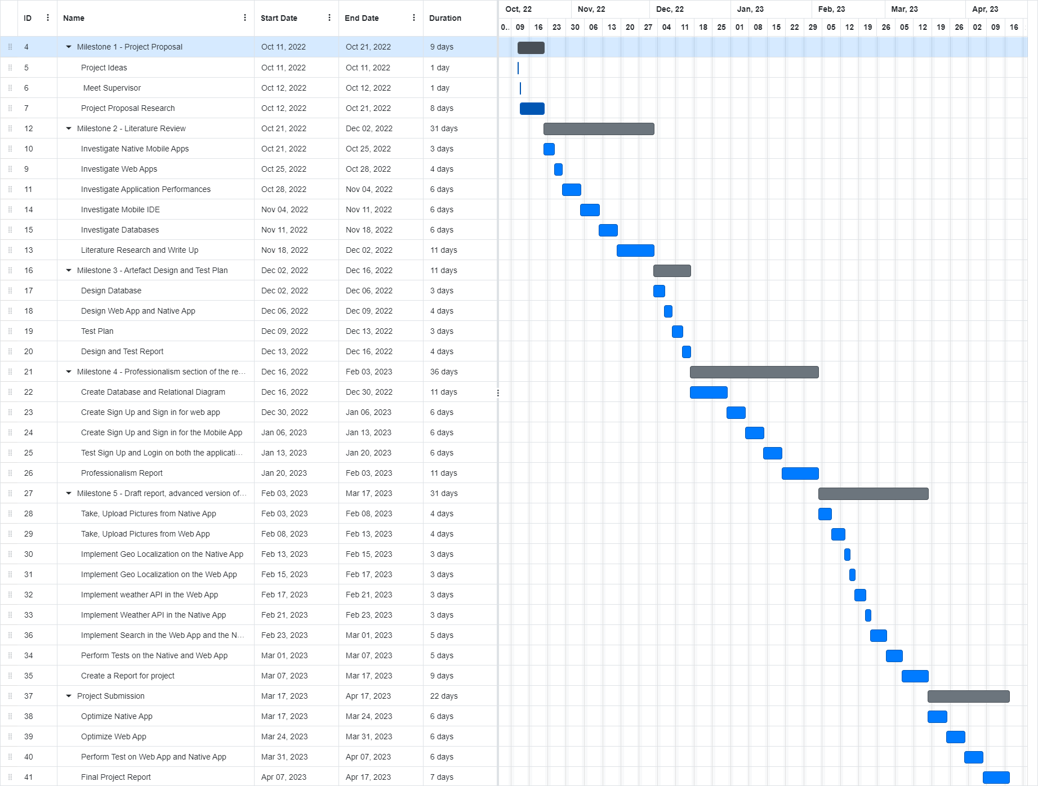

References and Bibliography
Alix Bergeret, 4CS071 Internet Architecture, University of Wolverhampton . 2021.
Banks, A. and Porcello, E. (2020) Learning React. Sebastopol: O'Reilly Media, Incorporated.
Google Android Studio Documentation.
Available at: https://developer.android.com/docs
(Accessed: Oct 10,2022).
Google and Firebase Cloud Firestore.
Available at: https://firebase.google.com/docs/firestore
(Accessed: 13/11/2022).
M, M. (2022) Essential JavaScript Libraries and Frameworks You Should Know About.
Available at: https://code.tutsplus.com/articles/essential-javascript-libraries-and-frameworks-you-should-know-about--cms-29540
(Accessed: 11/10/2022).
Ma, Y., Liu, X., Liu, Y., Liu, Y. and Huang, G. (2018) 'A Tale of Two Fashions: An Empirical Study on the Performance of Native Apps and Web Apps on Android', (5, 17), 990-1003. 10.1109/TMC.2017.2756633.
Martin, R.C. (2008) Clean Code: A Handbook of Agile Software Craftsmanship. Pearson.
Oracle (a) Oracle Cloud Autonomous Database.
Available at: https://docs.oracle.com/en-us/iaas/autonomous-database-shared/index.html
(Accessed: 11/10/2022).
Oracle (b) Relational Databases.
Available at: https://www.oracle.com/uk/database/what-is-a-relational-database/
(Accessed: 11/10/2022).
w3Schools React Tutorial.
Available at: https://www.w3schools.com/react/default.asp
(Accessed: 11/10/2022).
Wieruch, R. (2022) The road to React. Wroclaw: Amazon Fulfilment.
Xiao, P. (2019) Java Programming for Mobile Applications part of Practical Java programming for IoT, AI, and Blockchain. Indianapolis: Wiley.

Additional Information

Resources
The resources that will be used for the development of this project will all be open source or offered by the University of Wolverhampton. For the testing part I will use devices that are already owned by myself and/or emulate the conditions on a software.

Client
For this project Frommholz Ingo, supervisor, and the reader (unknown) will be acting as the clients.

